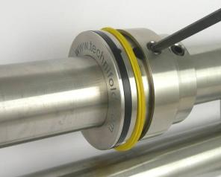
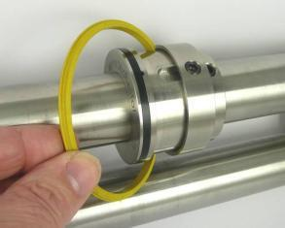

--------------------------------------------------------------------------------------------------------------------------------------------------------------------------------------------------------------------------------------------------

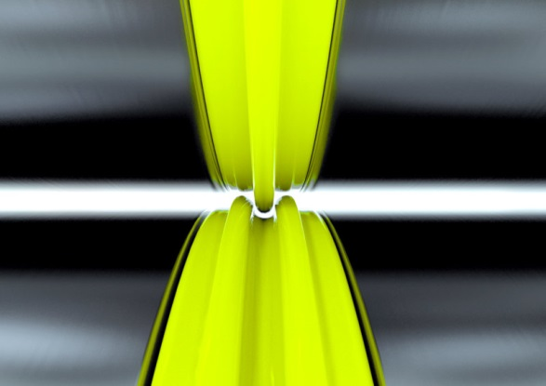
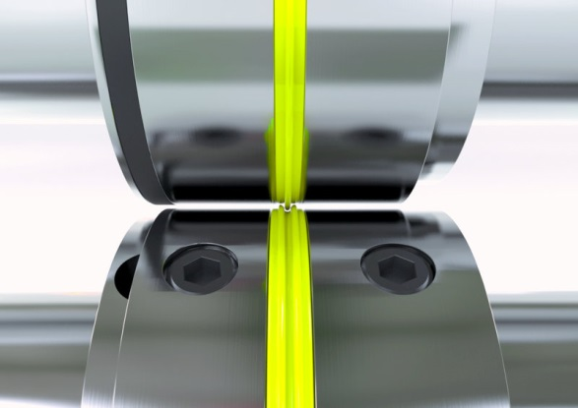

----------------------------------------------------------------------------------------------------------------------------------------------------------

4 Check the roller pressure settings by simply inserting a strip of 100 gsm paper into the roller callipers at each side of the machine. Place strips of the same paper at each side of the roller and check the grip pressure holding the paper between the roller. You should be able to gently pull out the strip with only a slight resistance. If the pressure is not correct the calliper pressure adjustment mechanism must be adjusted so that equal pressure is achieved. Failure to carry out the operation my result in sheets going out of square as the sheet passes through the rollers.





